

As we all work to budget protein costs in our food budget, pork is a great option to consider adding to your menu. Pork is a nutritious source of protein. It contains other nutrients including thiamin, niacin, riboflavin, zinc, potassium, and phosphorus; all of which play an important role in the growth and maintenance of muscle and other body tissues.
My Plate recommends five to six ounces of lean protein per day in our diets. Lean cuts of protein include tenderloin, sirloin pork chops, boneless top loin, ground pork, roast, and center/rib chops. Just three ounces of pork tenderloin contains 22 grams of protein and approximately three grams of fat. That is a great ratio for protein versus fat intake.
I enjoy the flexibility of spices you can use with pork as well. It can transition from traditional barbeque to your favor Mexican food easily. Dry-heat methods of cooking include grilling, broiling, stir fry, and roasting. You can also prepare pork using a moist-heat method, such as stewing or braising.
Pork consumption also supports many local businesses and small farms in our area. We have several farmers in the Amarillo/Canyon area raising hogs as well as large production facilities in the Oklahoma Panhandle. Supporting our agricultural producers ensures a strong economy for schools and communities.
Please feel free to contact me at the office if you would like additional information!
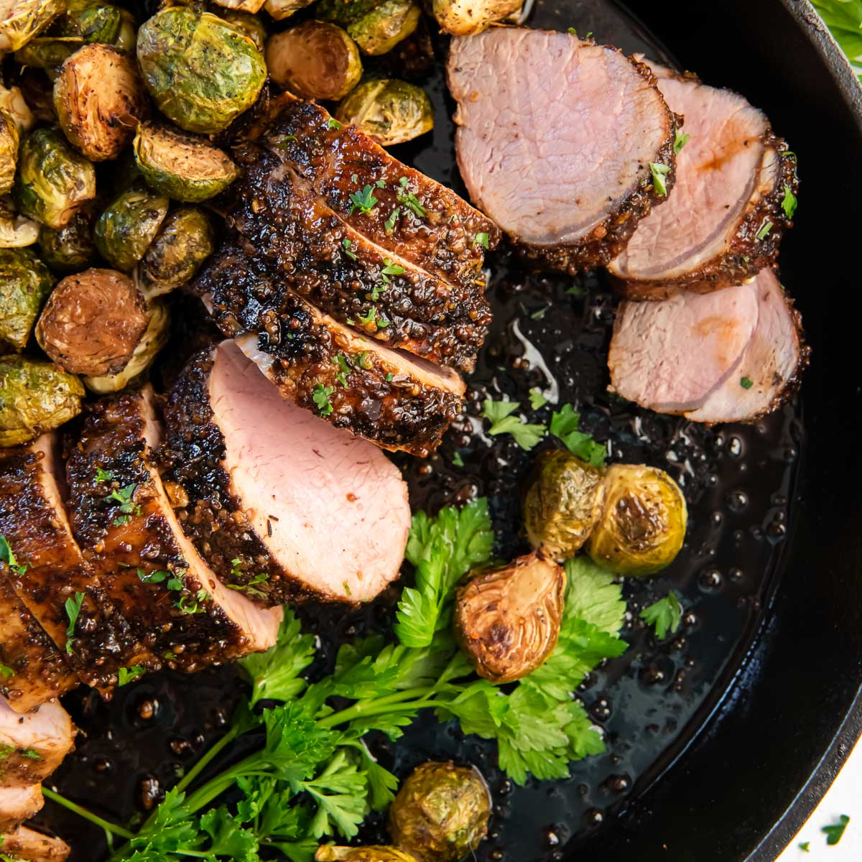
Megan Eikner
CEA – AG/NR
Texas A&M AgriLife Extension – Potter County

