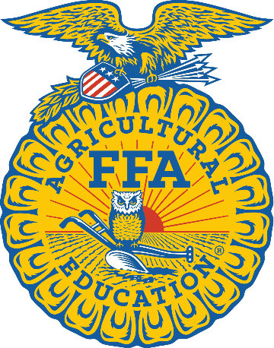


ZAVALA AGRICULTURE
EXPOSITION
2025-2026
RECORD BOOK

Personal Information Page
2025-2026

Name |  |  |  | County
Age Division |  |  |  | Category
Number of years in 4-H or FFA |  |  |  | Number of years in Main Project
(excluding Clover Kid years)
Address |  |  |  | Home Phone
City, State, Zip |  |  |  | Mobile Phone
Best Email
Date of Birth |  |  |  | School Grade
Place of Residence
Name of your 4-H Club or FFA Chapter
Number of members in your 4-H Club or Chapter
4-H/ FFA Member Signature |  |  |  |  |  |  |  | Date
Parent Signature |  |  |  |  |  |  |  | Date

4-H/ FFA Story & Photo Portfolio
Tell us about what made you join 4-H or FFA. How has 4-H or FFA made an impact in your life? What have you learned for this project? What has been your favorite part of being in 4-H or FFA? Etc.

4-H/ FFA Story & Photo Portfolio

4-H/ FFA Story & Photo Portfolio

2025-2026
Record Book Report Form
SECTION I – PROJECT EXPERIENCES QUESTIONS
Please answer the following questions to the best of your knowledge.

How much did your project cost, when first purchased?

How many hours did you work with your project? (Per day or week)

What feed did you use? (Example: grain; name of feed)

How much protein and crude fat was included in your feed? What did your feed consist of? (Example: Protein 10%, Crude fat 16%)

How much did you spend on feed for the project year?

How many bags of feed did you feed in the project year?

How much did you feed each day? (1/2 lb, 1 lb, 2 lbs, etc.)

How much hay was purchased in the project year?

What protein or supplements did you use, if any?

What was a challenge you encountered with your project?

2025-2026
Record Book Report Form
SECTION III – COLLEGE & CAREER EXPLORATION
As of today, what career would you choose?
Write what made you choose this career path? What have you learned throughout your project year that can be used as a skill in the future? Explain how your project has helped you prepare for this career path. SENIORS ONLY

