
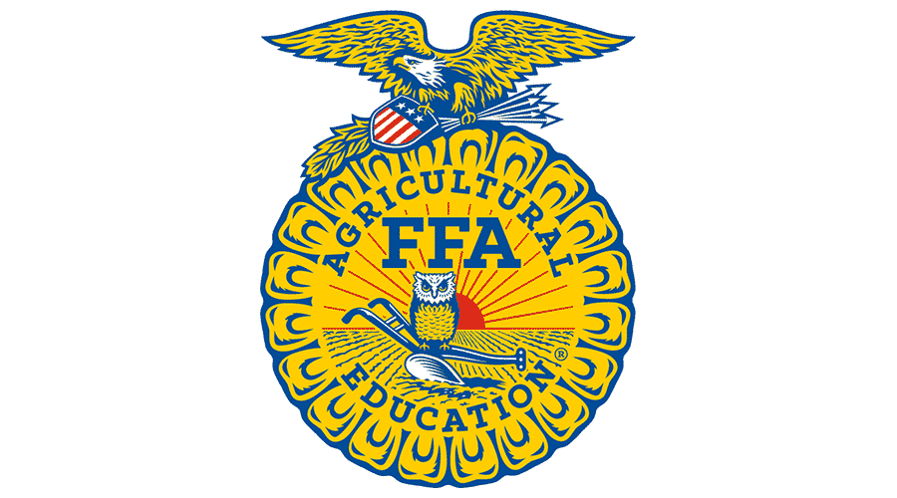

Zavala County Junior Livestock Show

2025-2026
Non-Animal Record Book

Personal Information Page
2025-2026

Name |  |  |  | Project
Age Division (Jr, Int, Sr) |  |  |  | Category
Number of years in 4-H or FFA |  |  |  | Number of years in Main Project
(excluding Clover Kid years)
Address |  |  |  | Home Phone
City, State, Zip |  |  |  | Mobile Phone
Best Email
Date of Birth |  |  |  | School Grade
Place of Residence
Name of your 4-H Club or FFA Chapter
Number of members in your 4-H Club or Chapter
4-H/ FFA Member Signature |  |  |  |  |  |  |  | Date
Parent Signature |  |  |  |  |  |  |  | Date

Non-Animal Categories:
- Photography
- Food
- Arts & Crafts
- Fashion
- Ag Mechanics or Industrial Arts
Project Story
(This story should reflect the story of your non-animal project. Tell us how you completed your project. Why did you pick this project? *Include pictures*
______________________________________________________________________________
______________________________________________________________________________
______________________________________________________________________________
______________________________________________________________________________
______________________________________________________________________________
______________________________________________________________________________
______________________________________________________________________________
______________________________________________________________________________
______________________________________________________________________________
______________________________________________________________________________
______________________________________________________________________________
______________________________________________________________________________
______________________________________________________________________________
______________________________________________________________________________
______________________________________________________________________________
______________________________________________________________________________
______________________________________________________________________________
______________________________________________________________________________
______________________________________________________________________________
______________________________________________________________________________
______________________________________________________________________________
______________________________________________________________________________
______________________________________________________________________________
______________________________________________________________________________
______________________________________________________________________________
______________________________________________________________________________
______________________________________________________________________________
______________________________________________________________________________
______________________________________________________________________________
______________________________________________________________________________
______________________________________________________________________________
______________________________________________________________________________
List all items needed to begin, maintain, and complete this project. If any.
Item | Cost
1.
2.
3.
4.
5.
6.
7.
Total cost of project | $

Ethics statement:
I certify that as a 4-H or FFA member this was my project and I did the majority of the work and learned about this project. Parents, by signing this form, you certify that this is your child’s project.

Signature of 4-H or FFA member completing project:____________________ Date:_________
Signature of parent:_______________________ Date:_________

